E-commerce Database Design and Normalization (UNF to BCNF)
Geethanjali College of Engineering and Technology (UGC Autonomous), Cheeryal (V), Keesara (M), Medchal-Malkajgiri Dist., Telangana
B.Tech Computer Science and Engineering (AI & ML) · II Year · AR25 Curriculum · DBMS Project-Based Learning
Roll No. | Name
26R15A6603 | G. Angel
26R15A6604 | K. Akshaya
26R15A6605 | P. Shanmuka Sai Prabhath
26R15A6606 | R. Malavika
26R15A6607 | V. Chaithanya
Guide: Dr. K. Arpitha Sreenivasulu

1. Objective
This project starts from one deliberately unnormalized e-commerce order relation and normalizes it step by step through 1NF, 2NF, 3NF and BCNF. Each decomposition is justified with functional dependencies, checked for lossless join and dependency preservation, and implemented and tested in MySQL. The aim is to demonstrate normalization correctly, not to build a full commercial application.

2. Business Rules
- A customer can place many orders. Each order belongs to one customer and is shipped to one address.
- An order contains one or more items. Each item is a listing: one product sold by one seller at one price. A listing appears at most once per order; repeated units are recorded in quantity.
- The same product can be sold by several sellers, each through a separate listing.
- An order can have several payment attempts (for example one failed and one successful).
- An order is shipped as one shipment by one shipper (1 order = 1 shipment).
- A return is made against one order item. The refund percentage is entered per return and is not derived from the damage factor.
- A PIN code belongs to exactly one city and state (city means postal district).
- The price of a listing is fixed (a simplifying assumption, see Limitations).

3. Implementation Overview
The project is a set of MySQL scripts, run in the order shown below. All data is loaded with plain INSERT statements (no INSERT IGNORE), so any violation fails loudly instead of being silently skipped.
Order | File | Purpose
1 | unf.sql | Creates database ecommerce_pbl, resets all tables, creates Order_UNF (repeating groups as JSON arrays) and inserts three sample orders
2 | ecommerce-check.sql | Validates the source data: item subtotal + shipping = total, and successful payments = total
3 | ecommerce-1nf.sql | UNF to 1NF
4 | ecommerce-fd-analysis.sql | Documents functional dependencies and candidate keys, and tests each dependency against the data
5 | ecommerce-2nf.sql | 1NF to 2NF, with a lossless-join test
6 | ecommerce-3nf.sql | 2NF to 3NF; creates and loads the final schema, with lossless-join tests
7 | ecommerce-bcnf.sql | BCNF verification of the final schema
8 | ecommerce-normalization-report.sql | Row counts, keys, foreign keys, migration checks, a lossless-join PASS/FAIL summary and sample queries
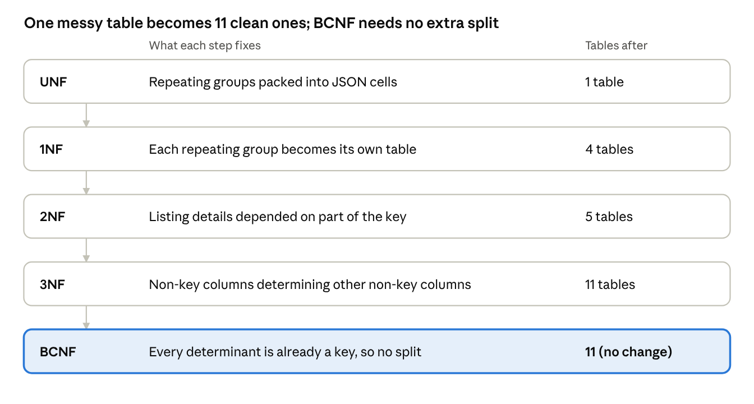
normalization stages · 5 steps, table count after each
UNF holds one table; 1NF gives four, 2NF five and 3NF eleven. BCNF changes nothing because every determinant is already a key.

4. The Unnormalized Relation (UNF)
Order_UNF(order_id, order_date, order_status, customer_id, customer_name, customer_email, customer_phone, address_id, apartment_name, street, city, state, pincode, order_items, payments, shipment_id, shipper_id, shipper_name, tracking_id, shipping_status, shipping_cost, total_order_amount, return_details)
The relation has three repeating groups. MySQL has no nested relations, so each group is stored as a JSON array in one column:
- order_items: listing_id, product_id, product_name, seller_id, seller_name, unit_price, quantity
- payments: payment_id, method, status, transaction_reference, amount
- return_details: return_id, listing_id, quantity_returned, return_date, damage_factor, refund_percentage, refund_amount
Sample data has three orders. Order 1001 (customer Arjun) has two items and one return, total 7600. Order 1002 (customer Priya) has one item, total 1950. Order 1003 (Arjun again) has two items, including the same product from two different sellers, and a failed payment followed by a successful one, total 5800. In every order the item subtotal plus 100 shipping equals the total, and successful payments equal the total (verified by ecommerce-check.sql).

Anomalies in the UNF design
- Update anomaly: Arjun's name, email and phone are stored in both order 1001 and order 1003. Changing the phone in one row leaves the data inconsistent.
- Insert anomaly: a new customer, seller or product cannot be recorded until an order exists for it.
- Delete anomaly: deleting order 1002 also deletes everything known about Priya and her address, because it is her only order.
- Redundancy: product names, seller names, shipper names and city/state values are repeated across rows.
- Repeating groups: items, payments and returns cannot be queried or constrained like ordinary columns.

5. Functional Dependencies and Keys
The dependencies come from the business rules above. Data tests can only refute a dependency, never prove it, so ecommerce-fd-analysis.sql tests every dependency against the data (all pass).
Relation | Functional dependencies | Candidate keys
Order | order_id → all other attributes | order_id (also shipment_id, since 1 order = 1 shipment)
Order | customer_id → customer_name, customer_email, customer_phone | not a key
Order | address_id → apartment_name, street, pincode, city, state | not a key
Order | pincode → city, state | not a key
Order | shipper_id → shipper_name | not a key
OrderItem | (order_id, listing_id) → quantity | (order_id, listing_id)
OrderItem | listing_id → product_id, product_name, seller_id, seller_name, unit_price | part of a key
OrderItem | product_id → product_name; seller_id → seller_name | not a key
Payment | payment_id → order_id, method, status, transaction_reference, amount | payment_id
Return | return_id → order_id, listing_id, quantity_returned, return_date, damage_factor, refund_percentage, refund_amount | return_id
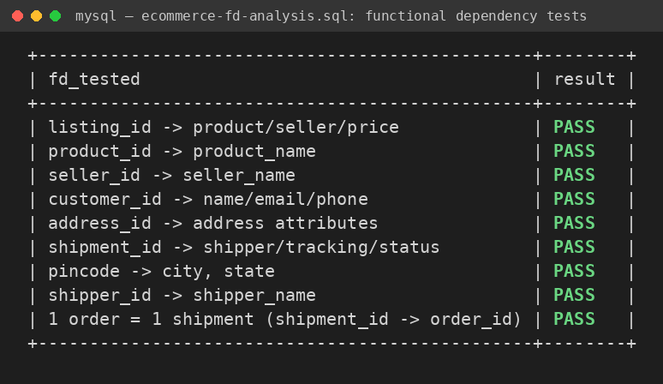
All nine dependency tests pass on the 1NF data (ecommerce-fd-analysis.sql).

6. First Normal Form (1NF)
Violation: the three repeating groups hold several values in one cell.
Decomposition: each repeating group becomes its own relation that carries order_id, and all remaining single-valued attributes stay together:
- Order_1NF(order_id, order_date, order_status, customer and address attributes, shipment attributes, shipping_cost, total_order_amount) with key order_id
- OrderItem_1NF(order_id, listing_id, product_id, product_name, seller_id, seller_name, unit_price, quantity) with key (order_id, listing_id)
- Payment_1NF(payment_id, order_id, method, status, transaction_reference, amount) with key payment_id
- Return_1NF(return_id, order_id, listing_id, quantity_returned, return_date, damage_factor, refund_percentage, refund_amount) with key return_id
Justification: every cell is now atomic and every relation has a primary key. The groups are kept separate on purpose: flattening items, payments and returns into one table would multiply every item by every payment and every return, creating false combinations and redundancy. Data is moved with JSON_TABLE, and row counts match (3 orders, 5 items, 4 payments, 1 return).

7. Second Normal Form (2NF)
2NF applies only where a key has more than one attribute.
- Order_1NF, Payment_1NF and Return_1NF have single-attribute keys, so partial dependencies are impossible. They are already in 2NF and are left unchanged.
- OrderItem_1NF has the key (order_id, listing_id), but listing_id → product_id, product_name, seller_id, seller_name, unit_price depends on only part of that key. This is a partial dependency.
Decomposition:
- Listing_2NF(listing_id, product_id, product_name, seller_id, seller_name, unit_price) with key listing_id
- OrderItem_2NF(order_id, listing_id, quantity) with key (order_id, listing_id)
Lossless: the common attribute is listing_id, which is the key of Listing_2NF, so the join cannot create or lose rows. Dependency preserving: (order_id, listing_id) → quantity lies wholly in OrderItem_2NF and listing_id → listing attributes lies wholly in Listing_2NF.

8. Third Normal Form (3NF)
3NF removes transitive dependencies, where a non-key attribute determines another non-key attribute.
In the order relation (key order_id):
- order_id → customer_id → customer_name, customer_email, customer_phone, so Customer is split out.
- order_id → address_id → apartment_name, street, pincode, and pincode → city, state, so Address and Pincode are split out.
- order_id → shipper_id → shipper_name, so Shipper is split out.
- shipment_id → shipper_id, tracking_id, shipping_status is not a violation. Under the rule 1 order = 1 shipment, shipment_id is itself a candidate key of the order relation (enforced with a UNIQUE constraint), so shipment data correctly stays in Orders.
In the listing relation (key listing_id):
- listing_id → product_id → product_name, so Product is split out.
- listing_id → seller_id → seller_name, so Seller is split out.
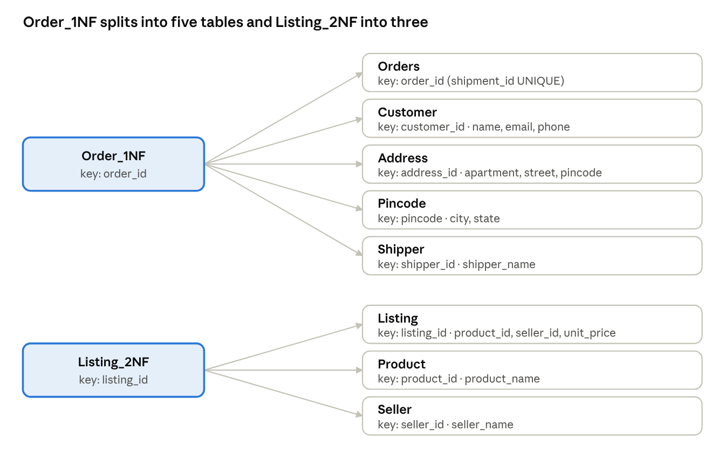
3NF decomposition · 2 source tables, 8 resulting tables
Each new table is keyed by the determinant it was split on, which is why every join back is lossless.
OrderItem, Payment and the return relation have no non-key determinants and are already in 3NF.
Housekeeping, not a normal-form rule: refund_amount can be computed as unit_price × quantity_returned × refund_percentage / 100, so it is not stored in the final return table. The report script recomputes it and confirms it equals the original value.
Lossless: every split is on a determinant that becomes the key of the new relation (customer_id, address_id, pincode, shipper_id, product_id, seller_id). Dependency preserving: every dependency sits inside one relation; listing_id → product_name still follows by transitivity through Listing and Product.

9. Boyce-Codd Normal Form (BCNF)
BCNF requires that for every non-trivial dependency X → Y, X is a superkey. Each relation of the 3NF schema was checked:
Relation | Determinant | Is it a key?
Customer | customer_id | Yes (primary key)
Pincode | pincode | Yes (primary key)
Address | address_id | Yes (primary key)
Shipper | shipper_id | Yes (primary key)
Product | product_id | Yes (primary key)
Seller | seller_id | Yes (primary key)
Listing | listing_id | Yes (primary key)
Orders | order_id; shipment_id | Yes (primary key; UNIQUE)
OrderItem | (order_id, listing_id) | Yes (primary key)
Payment | payment_id | Yes (primary key)
ProductReturn | return_id | Yes (primary key)
Conclusion: the 3NF schema already satisfies BCNF, so no further decomposition is performed and no extra tables are created. A 3NF relation can fail BCNF only when it has overlapping composite candidate keys with a non-key determinant; none of these relations does. Inventing a violation just to split again would be artificial.

10. Lossless Join and Dependency Preservation
Decomposition | Common attributes | Why it is lossless
OrderItem_1NF into Listing_2NF and OrderItem_2NF | listing_id | key of Listing_2NF
Order_1NF into Orders, Customer, Address, Pincode, Shipper | customer_id, address_id, pincode, shipper_id | each is the key of its new relation
Listing_2NF into Listing, Product, Seller | product_id, seller_id | each is the key of its new relation
The same property is verified in SQL: the decomposed tables are joined back and compared with the original relation using EXCEPT in both directions. Every such query returns zero rows, meaning nothing was lost and nothing was invented. The report script also rebuilds the full order header from the UNF data and compares it with the final tables.
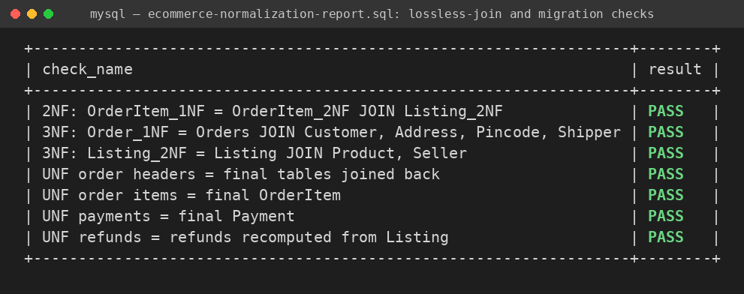
A row passes only when both EXCEPT directions return zero rows (ecommerce-normalization-report.sql).
Dependency preservation holds because every functional dependency listed in Section 5 is contained in a single final relation or follows from those that are, so all constraints are enforced by primary keys, unique keys and foreign keys without needing joins.

11. Final Schema (3NF = BCNF)
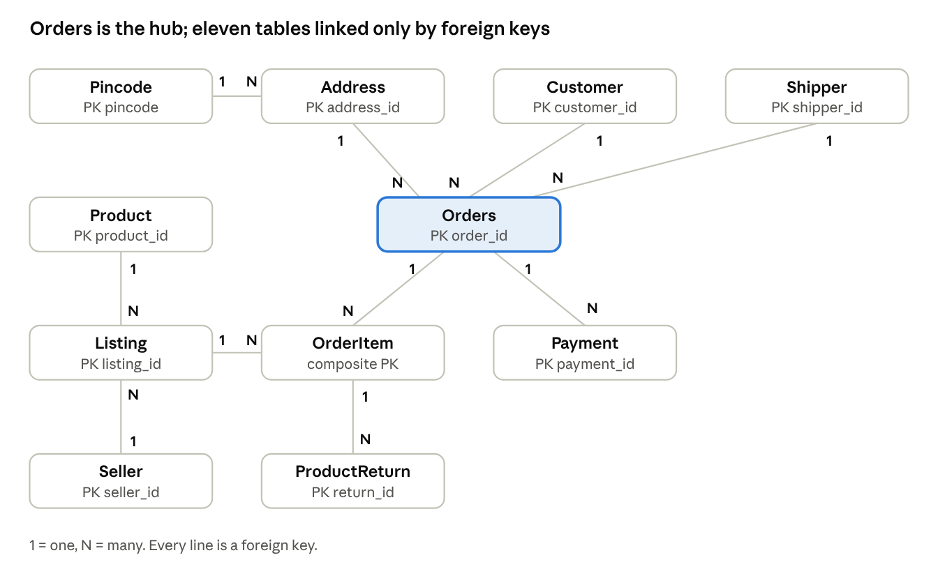
ER diagram · 11 entities, 10 one-to-many relationships
Customers, addresses and shippers feed into Orders; items, payments and returns hang off it, and listings link products to sellers.
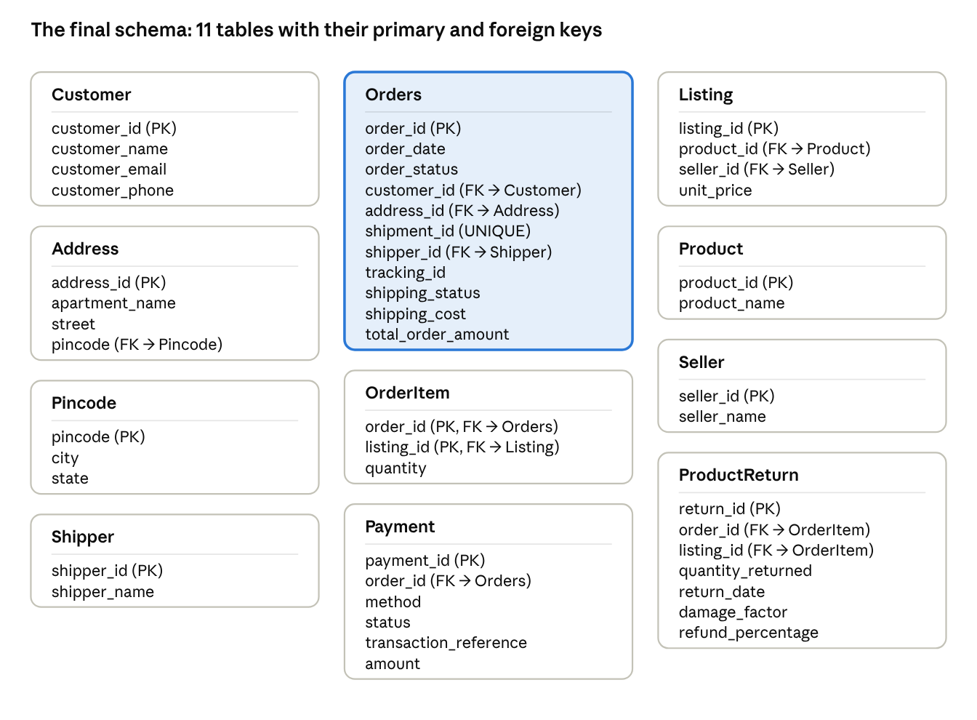
relational schema · 11 tables with all columns and keys
Orders (highlighted) is the only table that references customers, addresses and shippers; ProductReturn references a specific order line through the pair (order_id, listing_id).
Table | Primary key | Foreign keys
Customer | customer_id | none
Pincode | pincode | none
Address | address_id | pincode → Pincode
Shipper | shipper_id | none
Product | product_id | none
Seller | seller_id | none
Listing | listing_id | product_id → Product, seller_id → Seller
Orders | order_id (shipment_id UNIQUE) | customer_id → Customer, address_id → Address, shipper_id → Shipper
OrderItem | (order_id, listing_id) | order_id → Orders, listing_id → Listing
Payment | payment_id | order_id → Orders
ProductReturn | return_id | (order_id, listing_id) → OrderItem
Constraints include NOT NULL on required columns and CHECK (quantity > 0) on item and returned quantities.

12. Testing and Results
- Source validation: for all three orders, item subtotal plus shipping equals the total, and successful payments equal the total (PASS).
- Dependency tests: all nine functional-dependency tests on the 1NF data pass.
- Row counts across stages: UNF 3 orders; 1NF 3 orders, 5 items, 4 payments, 1 return; final schema Customer 2, Pincode 2, Address 2, Shipper 2, Product 2, Seller 3, Listing 3, Orders 3, OrderItem 5, Payment 4, ProductReturn 1.
- Lossless-join and migration checks: all EXCEPT queries return zero rows, including the rebuild of the order header and the line items from the original UNF data.
- Rebuilt totals: recomputing each order total from Orders, OrderItem and Listing matches the stored total (PASS for 1001, 1002 and 1003).
- Refund check: the recomputed refund equals the original refund_amount of 4000.
- Negative tests: giving one customer a second phone number makes the dependency test report FAIL and the load stop with a duplicate-key error. Changing a stored refund makes the refund check return a row. Neither problem is silently hidden.
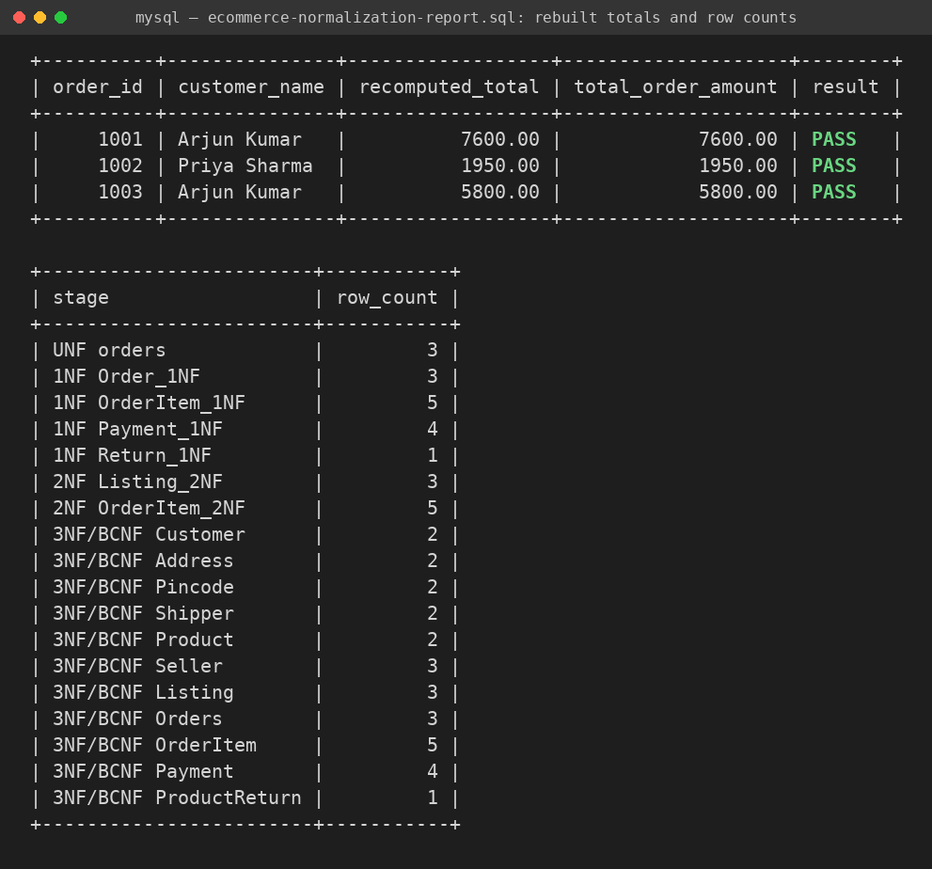
Rebuilt totals match for all three orders, and row counts agree across the stages.
The report script also includes queries that list the contents of each order with product and seller names, and that find orders with a failed payment attempt that were later paid (order 1003).

13. Limitations and Assumptions
- The dependency listing_id → unit_price assumes a listing's price never changes. A real system would store the price paid on each order item.
- 1 order = 1 shipment is a stated simplification; marketplaces often split multi-seller orders into several shipments.
- pincode → city, state assumes city means postal district.
- refund_percentage is treated as free input; if it were a fixed function of damage_factor it would be a further transitive dependency.
- total_order_amount is stored although it can be derived; it is validated by the checks rather than removed.
- The sample data is small, so the tests demonstrate correctness of the design rather than performance.

14. Conclusion
Starting from one relation with three repeating groups, the design was normalized to eleven relations in 3NF. Each step was justified by an actual dependency, never an invented one. The final schema is already in BCNF, which was shown by checking every determinant instead of forcing another split. Lossless-join tests, dependency tests and rebuild queries confirm that the MySQL implementation matches the normalization analysis and that the original data is fully recoverable.

